**More Exercises: HTTP and REST**

Problems for exercises and homework for the ["JS Front-End" course @ SoftUni](https://softuni.bg/trainings/3976/js-front-end-february-2023)

**Working with Remote Data**

For the solution of some of the following tasks, you will need to use an up-to-date version of the **local REST service**, provided in the lesson’s resources archive. You can [read the documentation here](https://github.com/softuni-practice-server/softuni-practice-server).

## Locked Profile

In this problem, you must **create a JS program** which **shows** and **hides** the additional information about users, which you can find by making a GET request to the server at address:

http://localhost:3030/jsonstore/advanced/profiles

The response will be an object with the information for all users. Create a profile card for every user and display it on the web page. Every item should have the following structure:

When one of the [**Show more**] **buttons** is clicked, the **hiden information** inside the div should be shown, only if **the profile is not locked**! If the current profile is **locked,** nothing should happen.

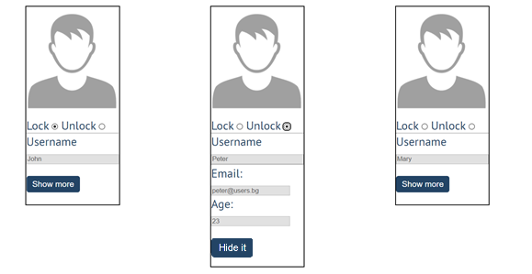

If the **hidden information is displayed** and we **lock** **the profile again**, the [**Hide it**] button should **not be working**! Otherwise, when the profile is **unlocked** and we click on the **[Hide it]** button, the new fields must hide again.

## Accordion

An **html** file is given and your task is to show **more**/**less** information for the selected article. At the start you should do a **GET** request to the server at adress: **http://localhost:3030/jsonstore/advanced/articles/list** where the response will be an object with the titles of the articles.

By clicking the **[More] button** for the selected **article**, it should **reveal** the content of a **hidden** div and **changes** the text of the button to **[Less]**. Obtain the content by making a **GET** request to the server at adress: **http://localhost:3030/jsonstore/advanced/articles/details/:id** where the response will be an object with property **id**, **title**, **content.** When the same button is clicked **again** (now reading **Less**), **hide** the div and **change** the text of the button to **More**. Link action should be **toggleable** (you should be able to click the button infinite amount of times).

**

Every item should have the **following structure**:

You are allowed to add new attributes, but do not change the existing ones.

## Fisher Game

Use the provided skeleton and the server.

### Login User

The **Login** page contains a form for existing user authentication. By given **email** and **password,** the app should login an existing user.

* After a **successful login** the **home page should be displayed**.
* In case of **error**, an appropriate error **message** should be displayed and the user should be able to fill in the login form again.
* Keep the user data in the browser's **session or locale storage**.
* POST request: [**http://localhost:3030/users/login**](http://localhost:3030/users/login)
* Payload to test in postman:  
  {  
   “email”: [george@abv.bg](mailto:george@abv.bg),

“password”: “123456”,

}

If the user is not logged in, all the buttons should be disabled except the "LOAD" button.

### Register User

By given **email** and **password,** the app should register a new user in the system.

* In case of **error** (eg. invalid username/password), an appropriate error **message** should be displayed, and the user should be able to **try** to register again.
* Keep the user data in the browser's **session or local storage**.
* After a **successful registration** the **home page should be displayed**.
* POST request: **http://localhost:3030/users/register**

### Logout

The logout action is available to **logged-in users**. Send the following **request** to perform logout:

* Get: **http://localhost:3030/users/logout**

Required **headers** are described in the documentation. Upon success, the **REST service** will return an **empty response**. Clear any session information you’ve stored in browser storage.

If the logout was successful, **redirect** the user to the **Home** page and change the button in navigation.

### Load catches

By clicking it you have to load all the catches from the server and render them like on the picture:

* Pressing the **[Load]** button should **list all** catches. (For all users)
* Pressing the **[Update]** button should send a **PUT** request, updating the catch in **http://localhost:3030/data/catches/:id**. (**Only for the creator of the catch**)
* Pressing the **[Delete]** button should delete the catch from **http://localhost:3030/data/catches/:id**. (**Only for the creator of the catch**)
* Pressing the [Add] button should submit a new catch with the values of the inputs in the fieldset with id="addFrom". (**Only for logged in users**)
* Button [Add] should be disabled in there are no logged in user.
* Buttons [Update] and [Delete] should be disabled if the currently logged-in user is not the author of the catch.

Each catch should have:

* angler - string representing the name of the person who caught the fish
* weight - floating-point number representing the weight of the fish in kilograms
* species - string representing the name of the fish species
* location - string representing the location where the fish was caught
* bait - string representing the bait used to catch the fish
* captureTime - integer number representing the time needed to catch the fish in minutes

Use the following requests to access your data:

* **List All Catches**
  + Endpoint - **http://localhost:3030/data/catches**
  + Method: GET
* **Create a New Catch**
  + Endpoint: **http://localhost:3030/data/catches**
  + Headers: X-Authorization: “….” (accessToken after login)
  + Method: POST
  + Request body (JSON): {"angler":"…", "weight":…, "species":"…", "location":"…", "bait":"…", "captureTime":…}
* **Update a Catch**
  + Endpoint:[**http://localhost:3030/data/catches/:catchId**](http://localhost:3030/data/catches/:catchId)
  + Headers: X-Authorization: “….” (accessToken after login)
  + Method: PUT
  + Request body (JSON): {"angler":"…", "weight":…, "species":"…", "location":"…", "bait":"…", "captureTime":…}
* **Delete a Catch**
  + Endpoint: **http://localhost:3030/data/catches /:catchId**
  + Headers: X-Authorization: “….” (accessToken after login)
  + Method: DELETE

## Furniture

Your task is to write the functionality of app, which shows list of furniture. By logged in user there is a possibility to buy furniture and list the bought products of the logged user. Also logged user can create new products (offers).

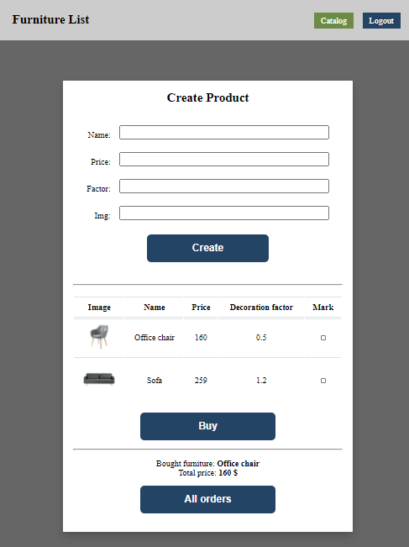

### Home page (not logged)

When the page is loaded the app should list all the furnitures in a table:

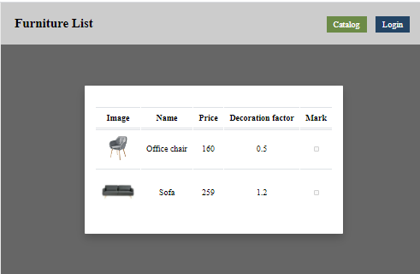

The checkbox should be disabled. You can send GET request on the URL: **http://localhost:3030/data/furniture**

### Auth page

When "Login" is clicked, the app should redirect to "Login page". There are two possibilities:

- to register a new user, send a POST request to the URL: **http://localhost:3030/users/register**

- to login, send a POST request to the URL: **http://localhost:3030/users/login**

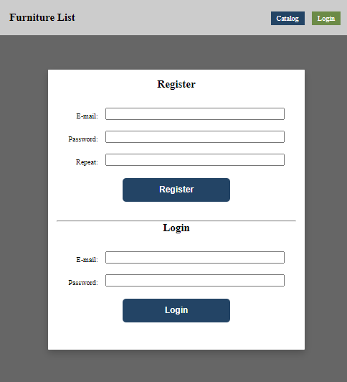

### Home page (logged in)

When the **"Create" button is clicked**, add a **new row to the table** for each piece of furniture with name**,** price, factor **and** img. Send POST request to: **http://localhost:3030/data/furniture**

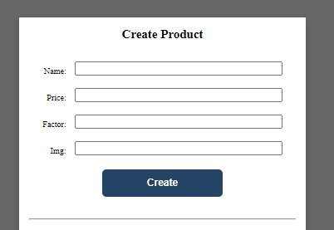

When the **"**Buy**"** button is clicked, get all **checkboxes that are marked** and save the information for these orders on the server. Make POST request to: **http://localhost:3030/data/orders**

When the "**All orders**" button is clicked, get all bought furniture of the current user, and show their names and the total price, as shown on the picture:

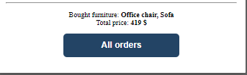

This could happen with GET request on this URL: [**http://localhost:3030/data/orders?where=_ownerId%3D{userId}**](http://localhost:3030/data/orders?where=_ownerId%3D%7buserId%7d)

## Submitting Your Solution

Place in a **ZIP** file the content of the given resources including your solution. Exclude the node_modules & tests folders. Upload the archive to Judge.

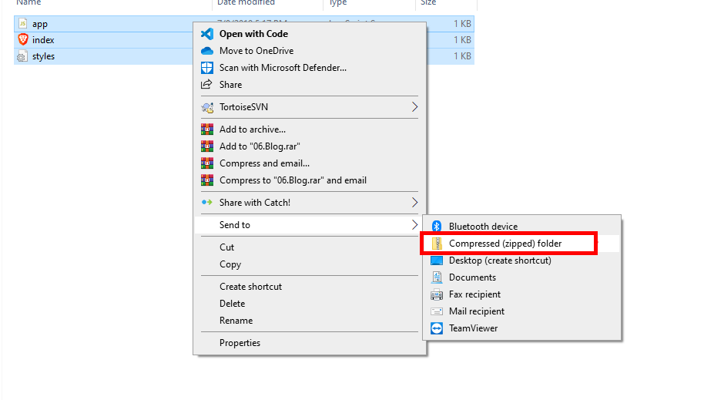

Картина, която съдържа текст

Описанието е генерирано автоматично

Картина, която съдържа текст

Описанието е генерирано автоматично